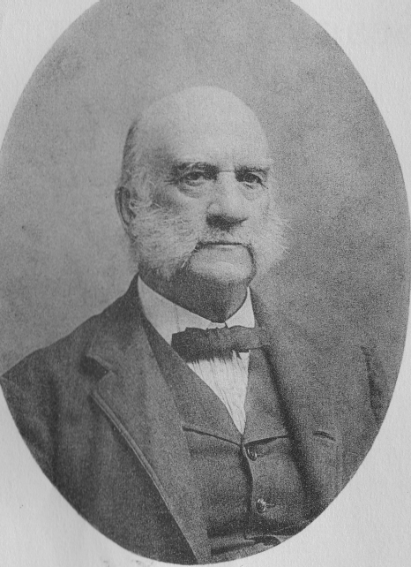

SEAMAN ASAHEL KNAPP
1833 – 1911

FOUNDER OF FARM DEMONSTRATION WORK

He organized the system of county farm and home demonstration agents and boys and girls clubs from which developed the Cooperative Extension Service of the United States. (From the Resolution of Congress authorizing a Knapp Memorial Tablet and Arch in Washington, 1933.)

Seaman A. Knapp
SCHOOLMASTER OF
AMERICAN AGRICULTURE
By Joseph Cannon Bailey


COLUMBIA UNIVERSITY PRESS
NEW YORK MCMXLV
PREFACE
MANY ABLE DIAGNOSTICIANS believe that American agriculture has been metamorphosed so profoundly by technology and capitalism that its end as a mode of life is at hand. Charles A. Beard declares: "Within less than one hundred years after Jefferson's death .. . the early dream of a nation chiefly sustained by free, independent, home-loving farmers of North European stock had been exploded." The implications of these beliefs increasingly concern us all.
While the most productive industrial nation on the globe has grown up in our cities, the proportion of our rural population has been dropping every decade and the trend is downward still. Philosophers of history have generally agreed that the mainstay of a democratic society is the free land-owning farmer. Our best statesmen long have been aware that the equilibrium of a wholesome social order needs a substantial share of its population as rural people. How this can be managed no one knows for certain, but those devoted to the democratic vision hope to keep enough of the citizenry on the soil to leaven our urban civilization. Should it prove possible to maintain the essence of the Jeffersonian dream through a reduced, but still substantial, farming population, then Seaman Knapp has played, and goes on playing, an important role in the social history of America.
Most social change today originates in the scientific laboratory, and it is the long lag between the discoveries of the scientists and the conversion of their dynamic findings to the people's use that creates the most pressing problems of our time. Seaman Knapp worked out an educational instrument that is the swiftest and most effective method yet contrived of getting badly needed technological and sociological knowledge from the colleges and laboratories to the groups farthest from the sources. His social invention, called the County Demonstration Agent System, bridges the gap between our rural communities and some fifty agricultural colleges and sixty experiment stations with their new-found information in the arts and sciences of husbandry. As much as anything this instruction helps keep farmers on their land.
How does a man beget an educational device that breaks with all tradition, and has such democratic potentialities? Seaman Knapp stood at the farthest pole from the popular conception of the genius
who works by inspiration and fine frenzy. Steady-going as an Erie barge boat, it is doubtful if he ever had a temperamental moment in his life. He was one of the breed molded by the demands of pioneering who, as his son writes, "had no time for foolishness."
The root of Knapp's idea seems to trace back to his boyhood and to have germinated through a lifetime of hard work at many seemingly unassociated occupations, maturing finally when Seaman was a man of seventy. Teacher, preacher, editor, banker, stockbreeder and plant explorer, his contribution to education, to the farmer, and to American social life came as the offshoot of his living. This book has sought to follow the slow ripening of the demonstration concept through the life of Seaman Knapp into the social invention upon which the Extension Service was erected.
The bulk of the material upon which this record of Knapp's work rests was consulted in various offices and in the library of the United States Department of Agriculture. The author is deeply appreciative of the courtesy and interest shown by its staff, several of whom are mentioned in the bibliographical note. Others whose assistance and comments are valued were Mrs. Eva Snyder, Miss Claribel Barnett, Director of Extension Work M. L. Wilson and the late Dr. B. T. Galloway. Of the remaining data, part was secured through the helpful cooperation of the New York Public Library; Columbia University Library; the Library of Congress; the Louisiana State University Library; the Iowa Agricultural College Library; the Howard Memorial Library, New Orleans; the Iowa Masonic Library, Cedar Rapids; the John Crerar Library, Chicago; and the Fort Edward Free Library, Fort Edward, New York.
Many individuals have been generous with aid in several forms. To Dr. Ramsey Spillman of New York City, the author owes much for the loan of a valuable manuscript biography of his father, Professor W. J. Spillman, and for a critical reading of the latter half of this volume. Mr. Russell Lord, editor of The Land, loaned his manuscript of The Agrarian Revival, read this manuscript and supported a correspondence over several years that provided much encouragement. Dr. J. A. Evans, author of a number of acute and accurate brief accounts of the early days of the demonstration work and one of Dr. Knapp's first lieutenants, supplied an elaborate commentary on the manuscript of this work which helped eliminate many imperfections. Major S. Arthur Knapp of Lake Charles, Louisiana, has been an unfailing source of information about his father and his family to the extent of a folder full of cheerfully gathered detail. He also read and commented on this manuscript. Others to whom the author is indebted include the late Honorable A. Frank Lever, the late Dr. Bradford Knapp, Dr. Albert Shaw, the Honorable David F. Houston, Mr. John D. Rockefeller, Jr., Dr. J. P. Bogue of Poultney, Vermont, and Mr. Jackson Davis of the General Education Board and Dr. C. B. Smith of the Department of Agriculture.
At Columbia University Professors O. S. Morgan and R. M. MacIver suggested phases for inclusion in this work and gave a helpful reading to the manuscript. Professors Allan Nevins, Merle Curti, and Edmund deS. Brunner also read the manuscript and went out of their way to supply both information and discriminating criticism. Grateful thanks are due Miss Matilda L. Berg of Columbia University Press for the patience and the enviable skill with which she managed her editorial assignment. The author's obligations to Professor Harry J. Carman run over so many years and touch so many subjects, in connection with this book and otherwise, that there is scarcely any way to render the appreciation felt except to say the book would never have seen print but for his aid and interest.

JOSEPH C. BAILEY
New York January, 1945

CONTENTS

PART 1 The Making of a Teacher and an Agriculturist
I A HOMESPUN CHILDHOOD
II. A CLASSICAL EDUCATION AND THE CLASSICAL EDUCATOR
III. THE REEDUCATION OF A PEDAGOGUE AND FARMER
IV. THE NEW EDUCATION FOR AGRICULTURE
V. A VENTURE IN LAND SETTLEMENT

PART 2 The Founding of the County Agricultural Agent System
VI. A PROGRAM TO PROMOTE AGRICULTURE IN THE SOUTH
VII. THE DISCOVERY OF THE AGRICULTURAL DEMONSTRATION TECHNIQUE
VIII. THE BOLL WEEVIL EMERGENCY
IX. THE ORGANIZATION OF THE FARMERS' COOPERATIVE DEMONSTRATION WORK
X. THE GROWTH OF THE FARMERS' COOPERATIVE DEMONSTRATION WORK
XI. EXTENSION OF THE COUNTY FARM AGENT SYSTEM

PART 3 The Institutionalization o f an Individual
XII. THE PASSAGE OF THE SMITH-LEVER ACT

